**E. Rivers Elementary**

**Date: 11/30/22**

**Time: 4:30pm**

**Location: Media Center and Zoom Zoom @ https://tinyurl.com/ythr5bj4**

1. **Call to order:** 4:37pm
2. **Roll Call**

|  |  |  |
| --- | --- | --- |
| **Role** | **Name** *(or Vacant)* | **Present or Absent** |
| **Principal** | **John Waller** | **Present** |
| **Parent/Guardian** | **Cason Given** | **Present** |
| **Parent/Guardian** | **Gregg Smolar** | **Present** |
| **Parent/Guardian** | **Gillian Maudlin** | **Arrived at 4:45pm** |
| **Instructional Staff** | **Keekwak Holloway** | **Present** |
| **Instructional Staff** | **Dr. Whitney Niles** | **Absent** |
| **Instructional Staff** | **Devon Rusert** | **Present** |
| **Community Member** | **Cecelia Moore** | **Absent** |
| **Community Member** | **Marc Hardy** | **Present** |
| **Swing Seat** | **Paul Hulsing** | **Present** |

**Quorum Established:** Yes

1. **Action Items** 
   1. **Approval of Agenda:** Motion made by: Hardy; Seconded by: Rusert

Members Approving: Hardy, Rusert, Given, Smolar, Holloway, Hulsing (6)

Members Opposing: 0

Members Abstaining: 0

**Motion** Passes

* 1. **Approval of Previous Minutes:** *List amendments to the minutes:*

Motion made by: Hardy; Seconded by: Holloway

Members Approving: Given, Smolar, Holloway, Rusert, Hardy, Hulsing (6)

Members Opposing: 0

Members Abstaining: 0

**Motion** Passes

* 1. **Strategic Plan Update: Go Team sets strategic priorities for school & monitors performance of school; administration responsible for implementing priorities & determining strategies to do so**

Motion made by: Given; Seconded by: Holloway

Members Approving: Given, Holloway, Smolar, Mauldin, Hulsing, Hardy, Rusert

Members Opposing: 0

Members Abstaining: 0

**Motion** Passes

* 1. **Ranking Strategic Plan Priorities**

Motion made by: Holloway; Seconded by: Given

Members Approving: Given, Holloway, Smolar, Mauldin, Hulsing, Hardy, Rusert

Members Opposing: 0

Members Abstaining: 0

**Motion** Passes

1. **Discussion Items** [See Principal's Report](https://www.atlantapublicschools.us/cms/lib/GA01000924/Centricity/Domain/14429/Principals%20Report%20-%20November%202022.pdf)
   1. **Fall ACES Presentation**: ACES = Accountability, Collaboration, Equity & Support / Dr. Waller has presented data to Supt. & cabinet:
      1. Enrollment: -24 total enrollment from last year → fairly stable enrollment / 15% ELLs, 10% w/ IEPs; 11% Gifted / Courtney Benner & Paul Hulsing work with teacher teams to extend differentiated options in class
      2. Hiring: hired 10 new-to-Rivers teachers this year, of those only 1 teacher new to profession
      3. Attendance: ~2% points down in terms of attendance YOY → pattern somewhat consistent across division / 6% increase in students who are chronically absent = absent 20% of the time, or more, since enrollment began
      4. Behavior: Relatively small # of suspensions this year
      5. MAP data: more kids performing at highest level; emergent level seemingly stagnant in terms of total #s, but individual students w/i that group have shown growth; MAP subgroup data: overall growth across student groups
   2. **Progress on the Strategic Plan Priorities**: Top 3 priorities have remained consistent across last year → aligned with cluster strategic priorities
   3. **Strategic Plan Update:**  Discussed at prior meetings in depth; plan remains unchanged from that time
   4. **Ranking Strategic Plan Priorities:**  Ranking the priorities will help determine how budget is allocated; in past year, GO Team has ranked top 3; this year, ranked all 9; Dr. Waller goal = organize the priorities in groups of 3

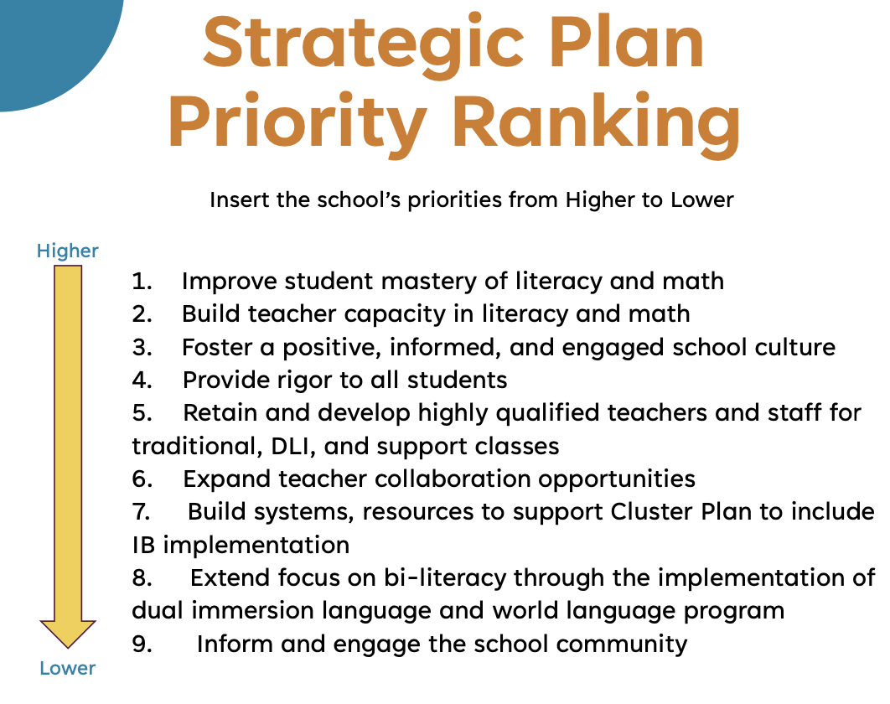

1. **Announcements** Cluster Meeting coming up - 4x a year; Holiday Performance on Friday at 1:$5pm
2. **Adjournment**

Motion made by: Smolar; Seconded by: Given

Members Approving: Given, Holloway, Smolar, Mauldin, Hulsing, Hardy, Rusert

Members Opposing: 0

Members Abstaining: 0

**Motion** Passes

**ADJOURNED AT** 5:35pm

-----------------------------------------------------------------------------------------------------------------------------

**Minutes Taken By:** Cason Given

**Position:** GO Team Member & Secretary

**Date Approved:** [Insert Date When Approved]